**Lab 12 Q1**

1. What is the output if the input is 25 5.50?

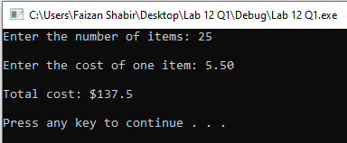

1. What is the output if the input is -55 2.8?

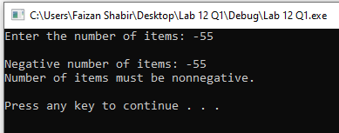

1. What is the output if the input is 37 -4.5?

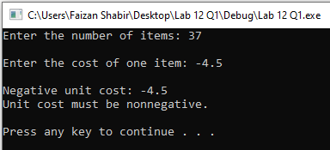

1. What is the output if the input is -10 -2.5?

